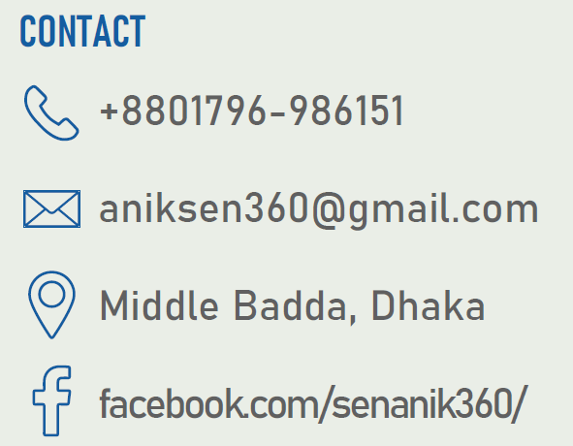
Anik Sen

Personal Profile -

I am currently doing my B.Sc. in Computer Science & Engineering (All credits completed excluding internship) at American International University-Bangladesh (AIUB). My major area is “Software Engineering”. I am looking for a job opportunity and preparing myself for the IT industry in near future. I’m consistently learning new software and tools and improving my programming skill.
Education and Training -

Institution | Degree | Department/Group | GPA/CGPA | Passing Year
American International University-Bangladesh | BSc | CSE | 3.94 out of 4 | 2023
Sreemangal Govt. College | HSC | Science | 4.83 out of 5 | 2018
Saint Martha’s High School | SSC | Science | 4.61 out of 5 | 2016
Experience -

Organization | Role | Period
a1qa (Minsk, Belarus) | QA Functional Testing Intern (Remote) | April, 2023 to Present
Youth School for Social Entrepreneurs – YSSE | Communications Intern (Remote) | March, 2023 to Present
Skills Summary -

- Proficient in multiple Programing Language- C, C++, Java, C#, Python[Numpy, Pandas], JavaScript, Php
- Proficient in Backend Framework- ASP.NET
- Experienced in HTML5, CSS3, Bootstrap5
- Experienced in Microsoft Office
- Database Management – My Sql, MS Sql, PL Sql
- Experienced in Software Testing tool- Selenium with Java
- Problem Solving in different online judge- Codeforces, Beecrowd, Hackerrank
- Teamwork
- Communication
- Leadership
- Language (Bangla and English)

- Tour Guide – BD
Projects -
- Using C# Web Form, based on the knowledge of Object Oriented Programming-2(C#) course
https://github.com/senanik360/tour-guide-C-sharp
- Online Super Shop
- Using basic Java. It’s a console application based on the knowledge of Object Oriented Programming-1(Java) course
https://github.com/senanik360/Java
- Digital Health Care
- I designed it in my Software Engineering course with UI. All the process is designed based on Agile methodology with proper budget plan.
- Tourism Management
- It’s a web application (Used HTML, CSS, PHP, JavaScript, MySQL )
https://github.com/senanik360/WebTech_course_project
- Learn and Teach
- Learn and Teach is a Web based and Android application where students and tutors will be benefited. It’s an ongoing project. We submitted proper plan and prototype in CTO Forum Hackathon 2022.
- Graphical view of Sea Beach
- A graphical view of sea beach using C++ OplenGL
https://github.com/senanik360/Computer-Graphics
Portfolio -

linkedin.com/in/senanik360/

github.com/senanik360

Participation and Certification -

- CTO forum Innovation Hack-a-Thon 2022. Successfully passed first round and reached second round (prototype).
Reference : https://www.ctoforumbd.org/
- Orbitax SUST SWE Technovent 2023(Brain Station 23 Hackathon). Successfully passed first round and participated final round at SUST campus for 36 hour non-stop on site hackathon.
Reference : https://technovent.sust.edu/
- Professional English Communication and Training. A training period under SEIP and BASIS, organized by WSDA New Zealand. The knowledge I gained will help me to understand and adapt to the general rules of professional communication to handle everyday workplace communication more effectively
- Php with Laravel. I’m doing this course under SEIP at Pencil Box training centre(Government funded). It’s a 60 days long training. Learned here basic front end development from the first season and now learning laravel framework for backend development.
- CISCO – IT Essentials. I’ve successfully achieved student level credential by completing IT Essentials course
Certification: https://github.com/senanik360/CISCO-IT-Essentials-Certificate/blob/main/CISCO%201/ANIKSEN-ICS_Spring_19_20-certificate.pdf
Awards / Honours -

- AIUB Academic Scholarship (Seven times) based on academic results.
Reference for checking criteria: https://cs.aiub.edu/undergrad/scholarship
Extra-Curricular Activities -

- Campus Ambassador [Team Lead] at ICT Olympiad Bangladesh – 2022 (Season 1)
- Executive Organizer at AIUB Arts Club
- The Duke of Edinburgh’s International Award (Bronze)
Hobbies and Interest -

- Travelling
- Playing Cricket
- Know new people
- Solving problem, learn new algorithm and build new logic.
References Available on Request -

- Dr. Akinul Islam Jony
Department Head, Computer Science, AIUB
Email : akinul@aiub.edu
- Dr. Kamal Uddin Sarkar
International Faculty, Department of Informatics, Universiti Malaysia Terengganu
Email : kusarker@umt.edu.my

